**TABLE 1** : CUSTOMERS

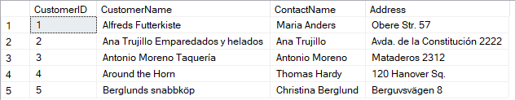

**TABLE 2** : EMPLOYEES1

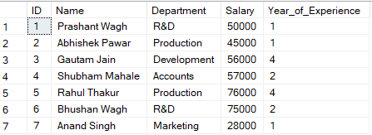

**TABLE 3** : EMPLOYEES2

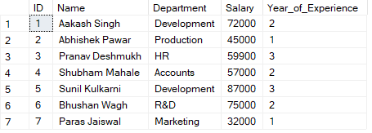

**DDL COMMANDS:**

DDL commands are used to create, manipulate, and modify the tables.

1. **CREATE** : To create a table

**Query** : CREATE TABLE customers(CustomerID INT PRIMARY KEY, CustomerName VARCHAR(255),ContactName VARCHAR(255), Address VARCHAR(255))

**Output** :

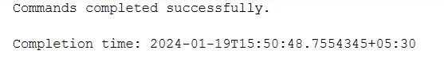

1. **ALTER** : To alter the columns in the table

**To add a column :**

**Query** : ALTER TABLE EMPLOYEES1 ADD NewColumn INT;

**Output**:

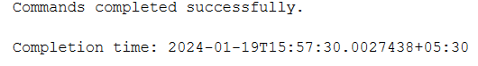

**To delete a column :**

**Query** : ALTER TABLE EMPLOYEES1 DROP COLUMN NewColumn;

**Output:**

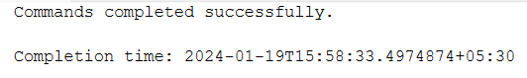

1. **DROP** : To delete the table

**Query**: Drop table customers

**Output**:

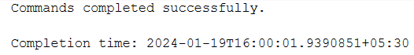

**DML COMMANDS:**

The DML commands in Structured Query Language change the data present in the SQL database. We can easily access, store, modify, update and delete the existing records from the database using DML commands.

1. **INSERT**: To insert data into the tables

**Query**: INSERT INTO customers (CustomerID, CustomerName, ContactName, Address)VALUES(1, 'Alfreds Futterkiste', 'Maria Anders', 'Obere Str. 57'),

(2, 'Ana Trujillo Emparedados y helados', 'Ana Trujillo', 'Avda. de la Constitución 2222'),

(3, 'Antonio Moreno Taquería', 'Antonio Moreno', 'Mataderos 2312'),

(4, 'Around the Horn', 'Thomas Hardy', '120 Hanover Sq.'),

(5, 'Berglunds snabbköp', 'Christina Berglund', 'Berguvsvägen 8');

**Output** :

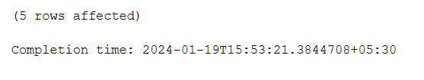

1. **SELECT** : To retrieve the data from the tables

**Query** : SELECT * FROM customers

**Output** :

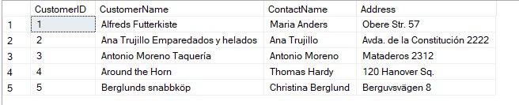

**WHERE :**

**Query** : SELECT * FROM customers WHERE CustomerID=1



**GROUP BY :**

**Query** : SELECT CustomerID,CustomerName FROM customers GROUP BY CustomerID, CustomerName

**Output** :

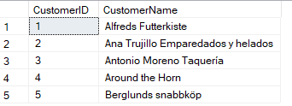

**ORDER BY :**

**Query** : SELECT CustomerID,CustomerName FROM customers GROUP BY CustomerID, CustomerName HAVING CustomerName LIKE '%na%'

**Output** :



1. **UPDATE** : To update the records in the table

**Query** : UPDATE employees1 SET Salary = 50000 WHERE ID = 1;

**Output** :

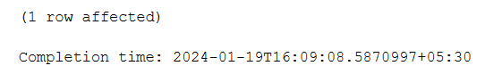

1. **DELETE** : To delete the records

**Query** : DELETE customers WHERE CustomerID=2

**Output** :

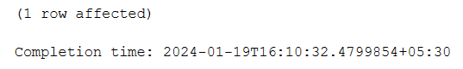

**OPERATORS :**

1. **AND** : SELECT * FROM employees1 WHERE Year_of_Experience=1 AND Department='Production'

**Output** :



1. **OR** : SELECT * FROM employees1 WHERE Department='R&D' OR Department='Production'

**Output** :

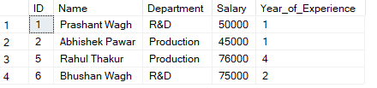

1. **IN** : SELECT * FROM employees1 where Department IN ('R&D','Production')

**Output** :

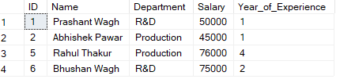

1. **NOT** : SELECT * FROM employees1 where Department NOT IN ('R&D','Production')

**Output** :

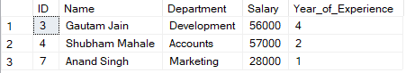

1. **LIKE** : SELECT * FROM employeeS1 WHERE Department LIKE 'P%';

**Output** :



1. **BETWEEN** : SELECT * FROM employees1 WHERE id BETWEEN 1 AND 4;

**Output**:

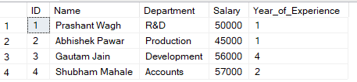

1. **ALL** : SELECT * FROM employeeS1 WHERE id = ALL (SELECT id FROM employeeS2 WHERE Department='Production');

**Output**:



1. **ANY** : SELECT * FROM employeeS1 WHERE id = ANY (SELECT id FROM employeeS2 WHERE Department='Production');

**Output**:



1. **EXISTS** : SELECT Name FROM employees1 WHERE EXISTS(SELECT id FROM employeeS2 WHERE Department='Production');

**Output**:

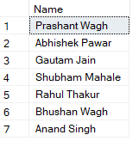

1. **SOME** : SELECT * FROM employeeS1 WHERE id < SOME (SELECT id FROM employeeS2 WHERE Department='Production');

**Output** :



**UNION** : SELECT *FROM employees1 UNION SELECT *FROM employees2;

**Output :**

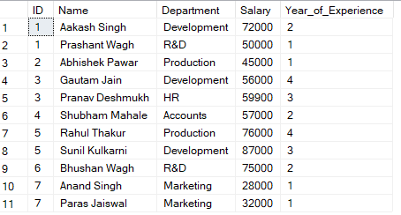

**UNION ALL** : SELECT *FROM employees1 UNION ALL SELECT *FROM employees2;

**Output :**

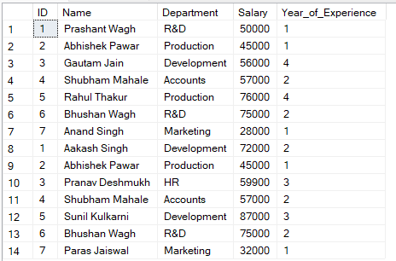

**INTERSECT** : SELECT *FROM employees1 INTERSECT SELECT *FROM employees2;

**Output :**

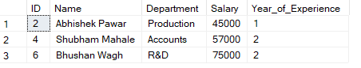

**MINUS** : SELECT *FROM employees1 MINUS SELECT *FROM employees2;

**Output :**

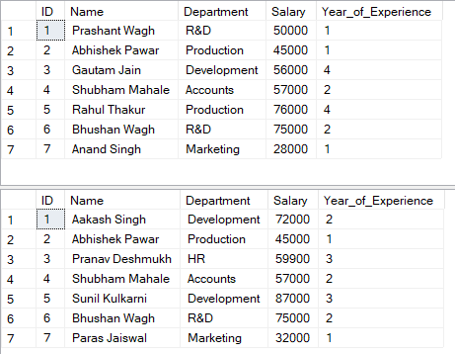

**DISTINCT** : SELECT DISTINCT DEPARTMENT FROM employees1;

**Output :**

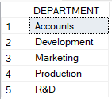

**DISTINCT & ORDER BY** : SELECT DISTINCT DEPARTMENT FROM employees1 ORDER BY Department DESC;

**Output :**

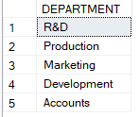

**DISTINCT & COUNT** : SELECT COUNT(DISTINCT DEPARTMENT) FROM employees1;

**Output :**



**NATURAL JOIN** : SELECT * FROM employees1 AS E1 JOIN employees2 AS E2 ON E1.ID=E2.ID

**Output :**

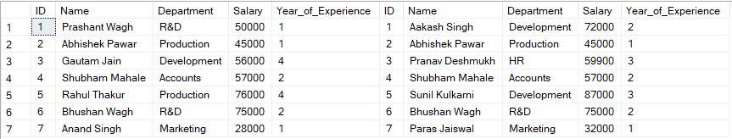

**INNER JOIN** : SELECT * FROM employees1 AS E1 JOIN employees2 AS E2 ON E1.ID=E2.ID

**Output :**



**LEFT JOIN** : SELECT * FROM employees1 AS E1 LEFT JOIN employees2 AS E2 ON E1.ID=E2.ID

**Output** :

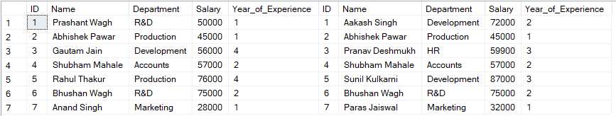

**RIGHT JOIN** : SELECT * FROM employees1 AS E1 RIGHT JOIN employees2 AS E2 ON E1.ID=E2.ID

**Output** :

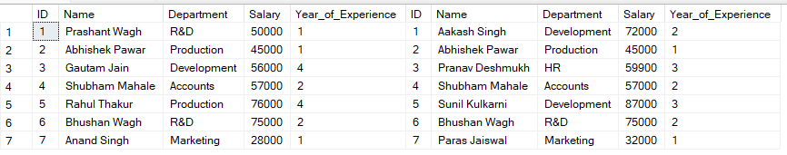

**FULL JOIN** : SELECT * FROM employees1 AS E1 FULL JOIN employees2 AS E2 ON E1.ID=E2.ID

**Output** :

